Lecturer Bot
When the lecturer bot is initially loaded into the game, he will be positioned inside the lecture room LT1B, which is located on the second level. At the same time, the lecturer bot will also broadcast to everyone so that we know the lecturer have arrived.

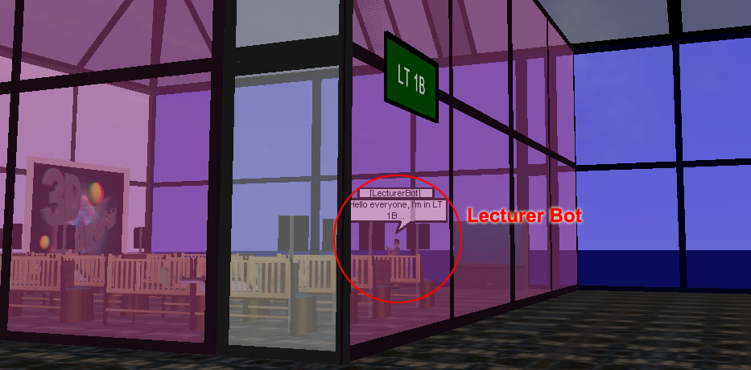
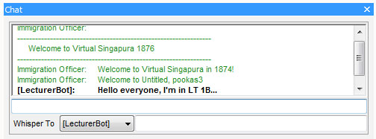

AIML Knowledge
Lecturer bot only contains a few AIML that is related to the course that they are currently teaching. As show in the screenshot below from Google code, this lecturer can only respond to topics such as general NTU questions, CMM and PSP.
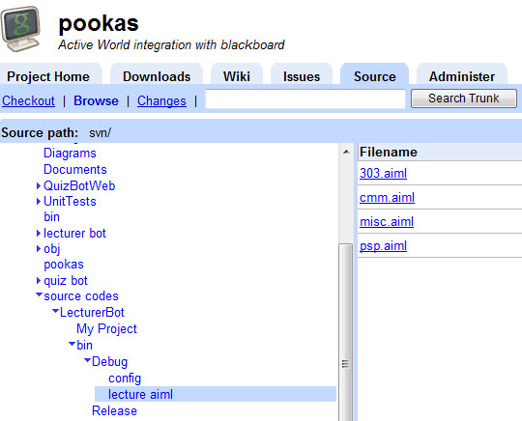
You may add new AIML or modify the files inside the folder “lecture aiml” if you wish to increase the knowledge of this lecturer bot. Adding new AIML files does not need to re-compile the bot.

To have a chat with the lecturer bot, you can enter the room and start typing your questions as shown in the screenshots below.

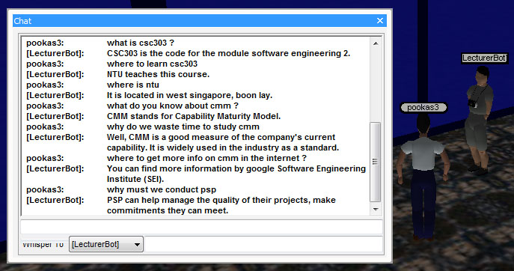

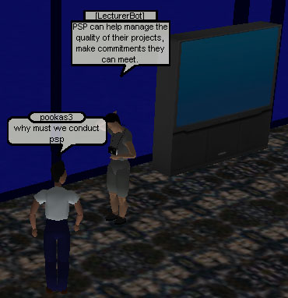

Announcement
The lecturer bot is programmed to login edventure automatically and constantly refresh the announcement page every 30 seconds. This is to ensure that the latest announcements will always be known to everyone.

To trigger the announcements, you have to include certain keywords in your chat. By default, the latest announcement is always the respond when the keywords “news” or “announcement” is found in the chat. For the second latest announcement, the keywords must include an additional “2nd" or “second”. For the third announcement, the keywords must include an additional “3rd" or “third”

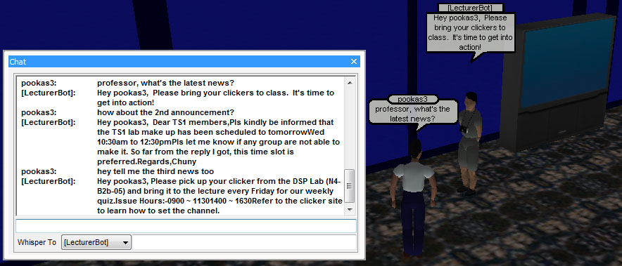

Conduct Lecture
When the keyword “start” and “lecture” is found in the chat message together, the lecturer bot will activate the lecture. Firstly, a large lecture screen will appear similar to the actual size present in the LT.
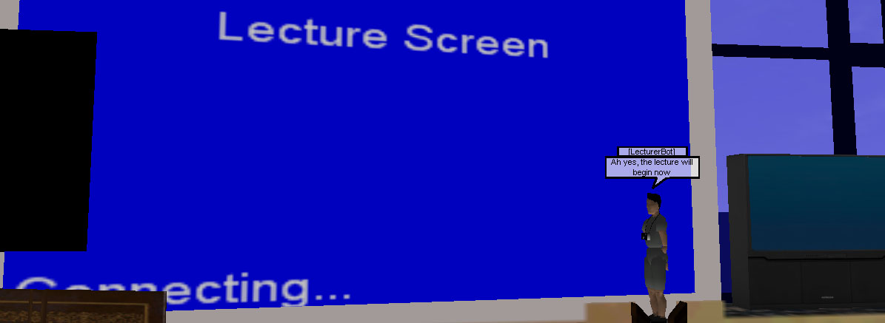

To play the recorded video from the edventure, the user simply click on anywhere in the screen. Clicking on the screen again will temporary pause the video. In other words, every user will be watching a different instance of the same video and this means that students can start and pause comfortably at their own pace.

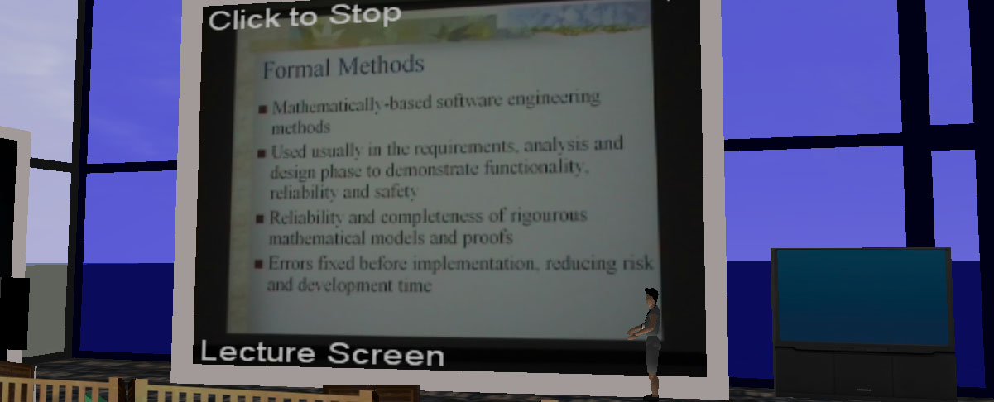

The lecturer bot will be standing beside the screen like what we actually see in NTU live lectures.

PowerPoint Slide
PowerPoint slides will only work when there is a lecturer bot currently loaded inside the game. It is located in the same room as the bot, directly beside the lecture screen.

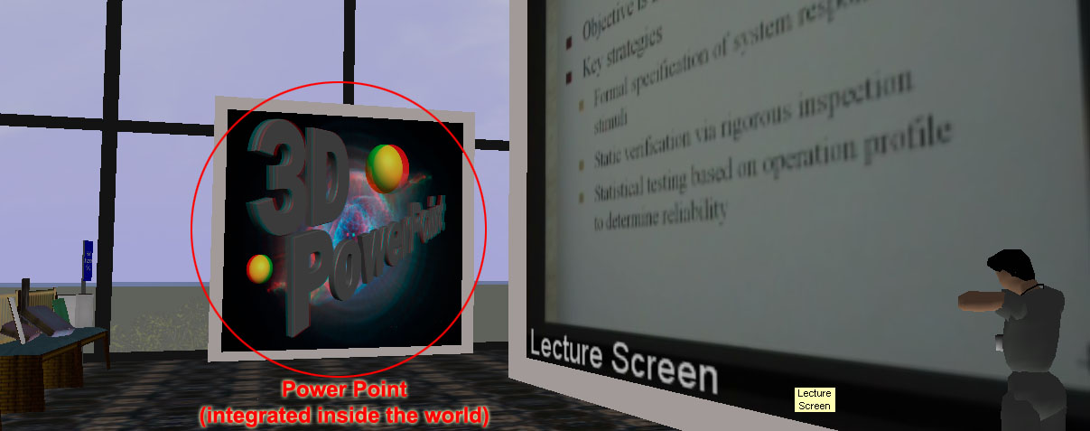

For this demo, we are using OCL lecture videos and OCL part 2 for the PowerPoint slides.

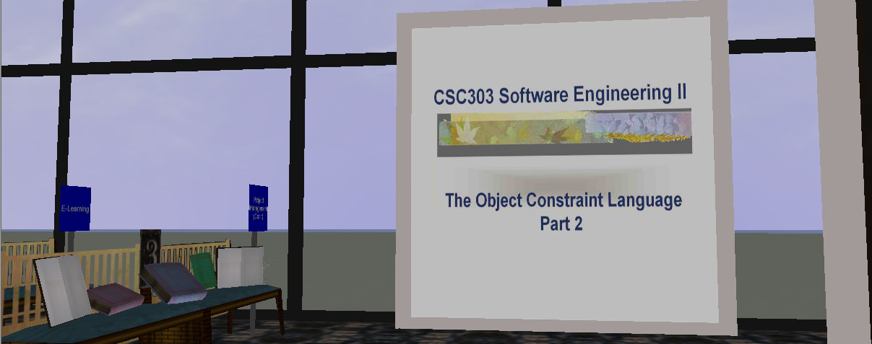

Mouse click will advance to the next slide.
Note: This power point slide is shared across every user.

Student Bot
When the student bot is initially loaded into the game, it will appear on the 2nd level, quiz area. The bot will say hello to inform everybody that he has enter the system.

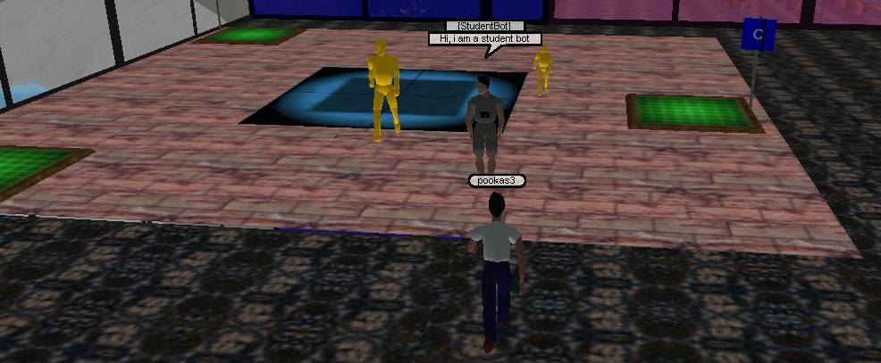

Random Walking
This bot is being programmed to have the ability to randomly walk around this level of the building. If a user mouse click, the student bot will report its name and coordinates.
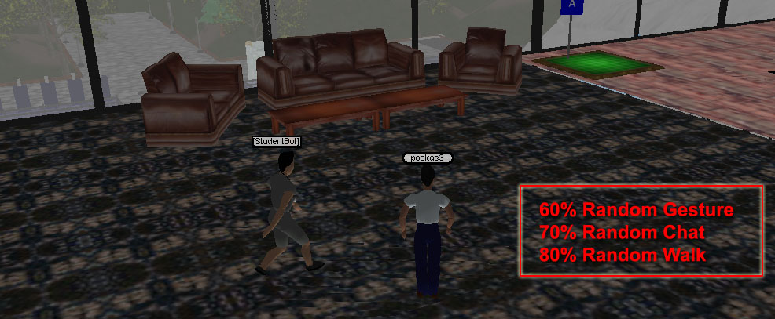

As shown in the screenshot above, the student bot is walking within the confined region that it is allowed to.

AIML Database
To have a highly unpredictable and interactive talking bot, we have downloaded a lot of aiml files for the student bot. The screenshot shows the amount of aiml files belong to the student.

